Let’s Build the Cloud, One Server at a Time!
GHC 2018 Workshop Instructions for Servers 23-25, 27
Niharika MATETI, RADHIKA SAKSENA, AKANKSHA GUPTA
2018

Instructions for Servers labeled 23-25, 27

Before you begin
- In this workshop you will be removing the components of a server and assembling it back. The workshop is for 30 minutes. You can take time to explore the server, but please ensure to put back all the components inside the server and close the top cover at the end of 30 minutes.
- Please take turns around the table for each instruction.
- The round label on the top of the server shows the server model and generation. The printed instructions provided to you are for the model of the server on your desk. If you believe you may have received instructions for a different model, please bring it to the presenters’ attention.
- You may need to apply some force to snap things into place. But if you are applying too much force or if you are not able to pull the components out, then you are doing something wrong. Check the instructions and try again.
- There are volunteers around to help you if you require any assistance.
- In most cases, you will not require a screwdriver. You should be able to loosen the thumbscrews easily. But if you need one, please ask the volunteers or the presenters for one.
- If you have a DL360 Gen10, study Figure 1 to understand the system board components and their location.
- If you have a DL360 Gen9, study Figure 2 to understand the system board components and their location.
- On some servers there is additional information on the bottom side of the top cover.

Removal Instructions
- Remove the top cover from the server.
- Lift the latch on the top cover.
- Slide the cover toward the rear of the server and then lift to remove the top cover from the chassis.
- Remove the 2 RAM DIMMS.
- See Figure 3 for a picture of a DIMM.
  - Open the DIMM slot latches located at the edges.
  - Lift the DIMM up and out of the DIMM slot.
- Remove all the fans.
  - See Figure 8
  - Grasp the fan and lift it straight up off the system board.
- Remove the power supply. Some servers have 2 power supplies, remove both of them. The power supplies are in the back of the server.
  - See Figure 11 for a picture of a power supply.
  - Push and hold the release latch to the left.
  - Grasp the power supply handle and pull the power supply from the bay
- Remove the PCI riser cage.
  - See Figure 6.
  - Grasp the riser cage at the touch points and lift it out of the chassis
- Remove the PCI card from the PCI riser cage.
  - See Figure 9 and Figure 10.
  - Carefully disconnect the expansion board from the riser board and remove.
- Remove the hard drive. The hard drives are in the front of the server. There is just 1 hard drive.
  - Press the red ejector button to release the handle.
  - Use the handle to slide out the hard drive.

Installation Instructions
- Install the Fans.
- See Figure 8.
- Align the fan with the guide pins on the chassis pan and slide it down until fully seated on the system board fan connector.
- Install the 2 RAM DIMMs. Check the number of processors installed in you server. If only 1 processor is installed, place the 2 DIMMs according to the alphabetic order (A and B slot for the installed processor). If 2 processors are installed, place each of the DIMMs in the A slot of each processor.
  - See Figure 3 for DIMM Installation
  - See Figure 4 for DIMM slots for a DL360 Gen10 Server.
  - See Figure 5 for DIMM slots for a DL360 Gen9 Server.
  - Ensure that the DIMM slot latches are open.
  - Locate the alignment notch on the DIMM and align it with the key in the DIMM slot.
  - Push the DIMM down firmly into the slot until the DIMM slot latches snap into place.
  - Ensure that the DIMM is fully inserted and properly seated in the slot.
- Insert the power supply into the power supply slot.
  - See Figure 11.
  - Slide the hot-plug power supply into the power supply bay until it is fully seated and clicks into place.
- Install PCI expansion board into the PCI riser cage.
  - See Figure 9.
  - Align the expansion board with the slot on the riser board and press the board into the slot until fully seated. Find a slot which is empty.
- Install the PCI riser cage.
  - Check Figure 7.
  - Align the connectors on the riser board with the slot on the system board.
  - Press down on the riser cage until the board is fully seated.
- Install the hard drive into bay 1. On some servers, check the front of the server for the hard drive bay numbering. On other servers there is a label on the top of the server which shows the hard drive bays numbering.
  - Press the ejector button to release the handle.
  - With the hard drive handle extended, insert the drive into the drive bay.
  - Close the drive handle to lock the hard drive into place.
- Replace the top cover.
  - To replace the top cover, align it to the chassis then slide it toward the front panel.
  - The latch should be open while sliding the cover.

DL360 Gen10 System Board Components

Figure 1: DL360 Gen10 System Board Components

Item Description
  - FlexibleLOM connector

  - Primary (processor 1) PCIe riser connector
  - System maintenance switch

  - Front display port/USB 2.0 connector
  - x4 SATA port 1

  - x4 SATA port 2
  - x2 SATA port 3

  - x1 SATA port 4
  - Front power/USB 3.0 connector

  - Optical/SATA port 5
  - Smart Storage Battery connector

  - Micro SD card slot
  - Chassis Intrusion Detection connector

  - Drive backplane power connector
  - Dual internal USB 3.0 connector

  - Type-a SmartArray connector
  - Secondary (processor 2) PCIe riser connector

  - System battery
  - TPM connector (optional)

  - Serial port connector (optional)

DL360 Gen9 System Board Components

Figure 2: DL360 Gen9 System Board Components

Item Description

- FlexibleLOM connector

- Primary (processor 1) PCI riser connector

- NMI jumper

- System maintenance switch

- Front VGA/USB 2.0 connector

- x4 SATA port 1

- x4 SATA port 2

- Backplane presence detect connector

- Optical/SATA port 5

- SATA port 4

- Front power/USB 3.0 connector

- HPE Smart Storage Battery connector

- Optional Location Discovery Services connector

- Drive backplane power connector

- microSD card slot

- Dual internal USB 3.0 connector

- Smart Array/HBA connector

- Secondary (processor 2) PCI riser connector

- System battery

- TPM connector

- Optional serial port connector

Installation of a DIMM

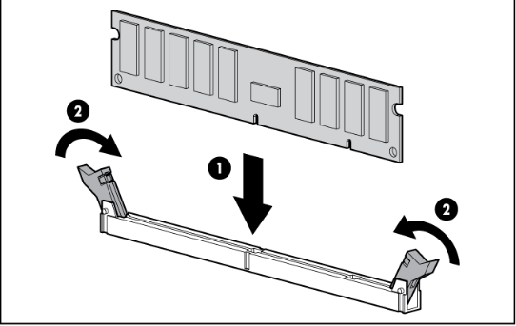
Figure 3: Install a DIMM

DL360 Gen10 DIMM Slots
Figure 4: DL360 Gen10 DIMM Slot Locations

DL360 Gen9 DIMM Slots

Figure 5: DL360 Gen9 DIMM Slots

Remove the PCI riser cage

Figure 6: PCI riser cage removal

Install the PCI riser cage

Figure 7: PCI Riser Cage Installation
Remove Fans
Figure 8: Fan removal

Remove PCI Card

Figure 9: Remove PCI Card

PCI
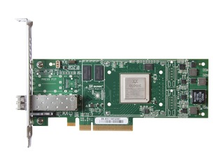
Figure 10: PCI expansion card

Power Supply

Figure 11: Insert Power Supply

